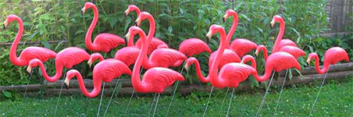

Are you a jokester? LOVE to prank your family, friends, or neighbor? Is there an event where you’d like to draw some attention?

Let us flock for you! For $30 we will set up flamingos in someone’s yard and then remove them once the flocking is complete. We strike at night, so the “flockee” will wake up to a very pink sight!

Your name:
Your phone # (optional):
Reason for flocking (birthday, just because, etc.):
Preferred flock date:
Address to be flocked:

To schedule your flocking please email this info. to: AnokaWT@mnwt.org
Or for more information visit http://anokawomenoftoday.weebly.com/flocking

[Phone]
[Phone]

Lorem Ipsum, Eram.

Lorem Ipsum, Eram.
[Phone]

Lorem Ipsum, Eram.
[Phone]

Lorem Ipsum, Eram.
[Phone]

Lorem Ipsum, Eram.
[Phone]

Lorem Ipsum, Eram.
[Phone]

Lorem Ipsum, Eram.
[Phone]

Lorem Ipsum, Eram.
[Phone]

